Website : <https://plantuml.com/>

Aim: To draw diagrams using **StarUML.**

1. **Class Diagram.**

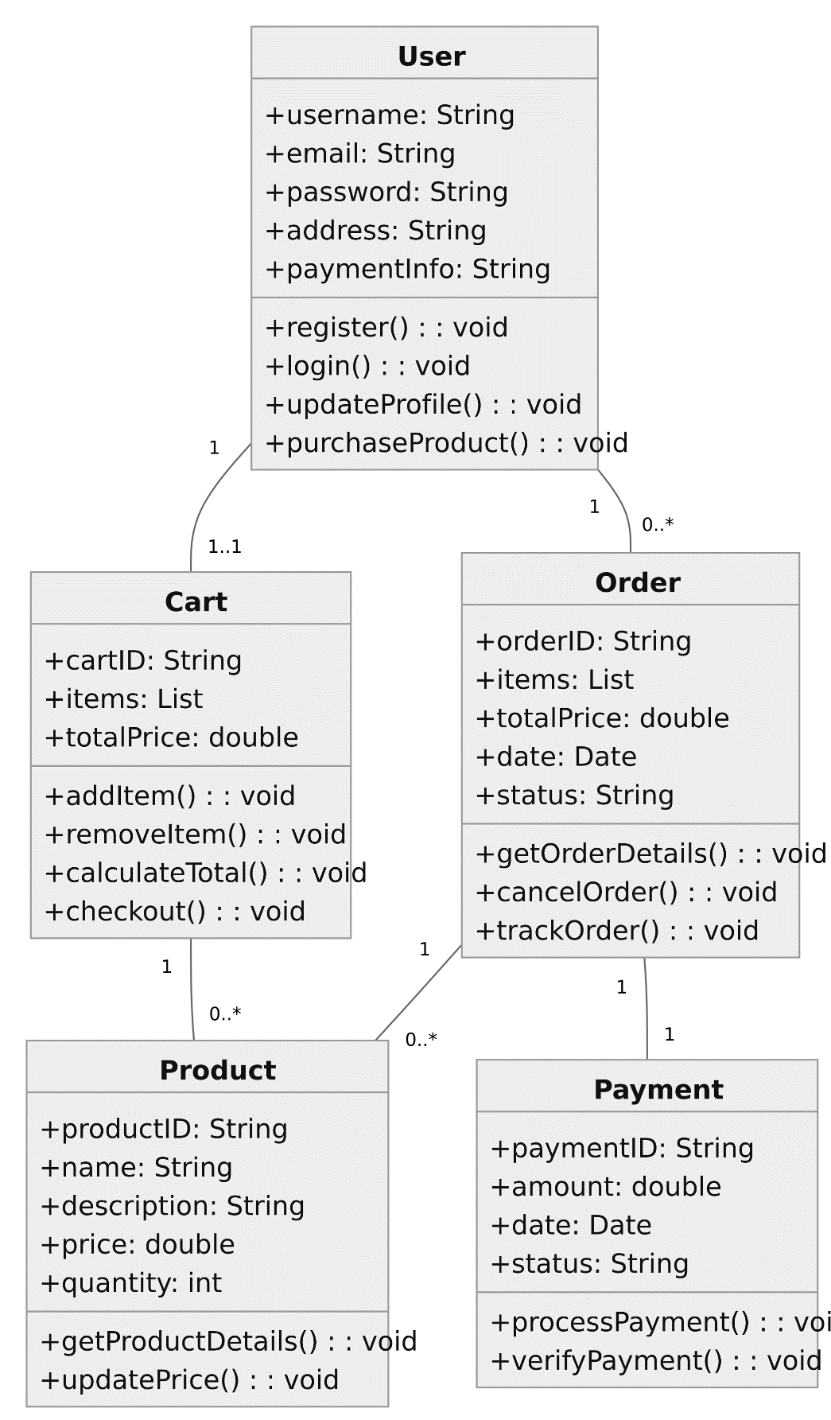

1. **Sequence Diagram.**

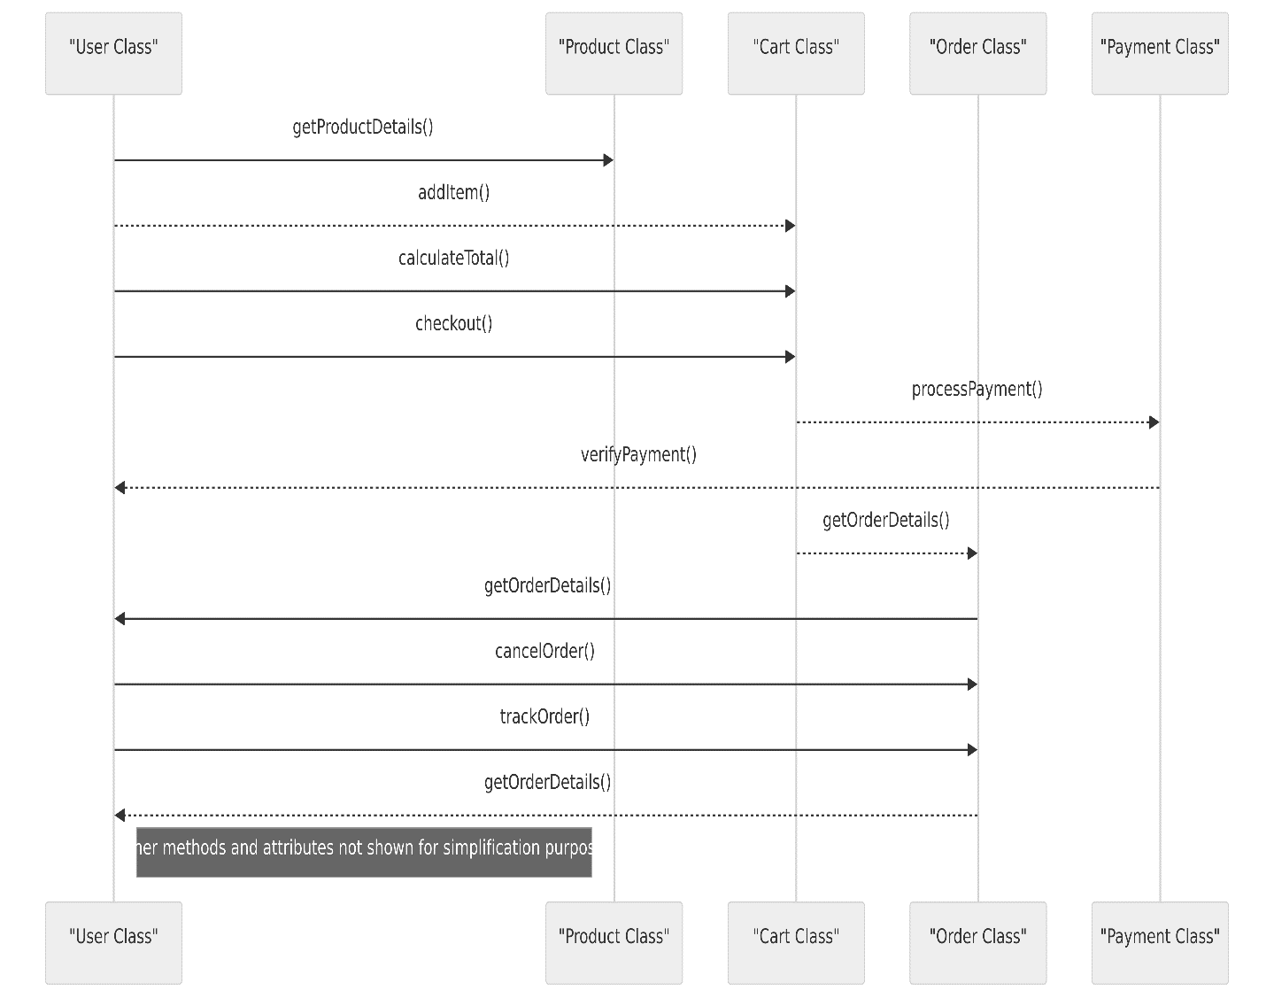

1. **Activity Diagram.**

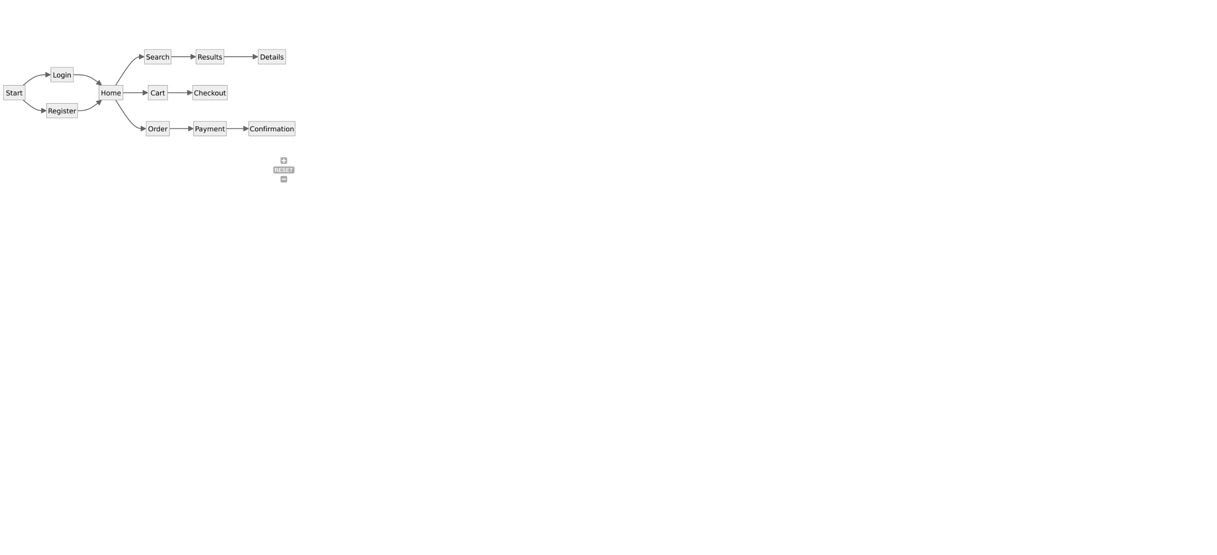

1. **State Diagram.**

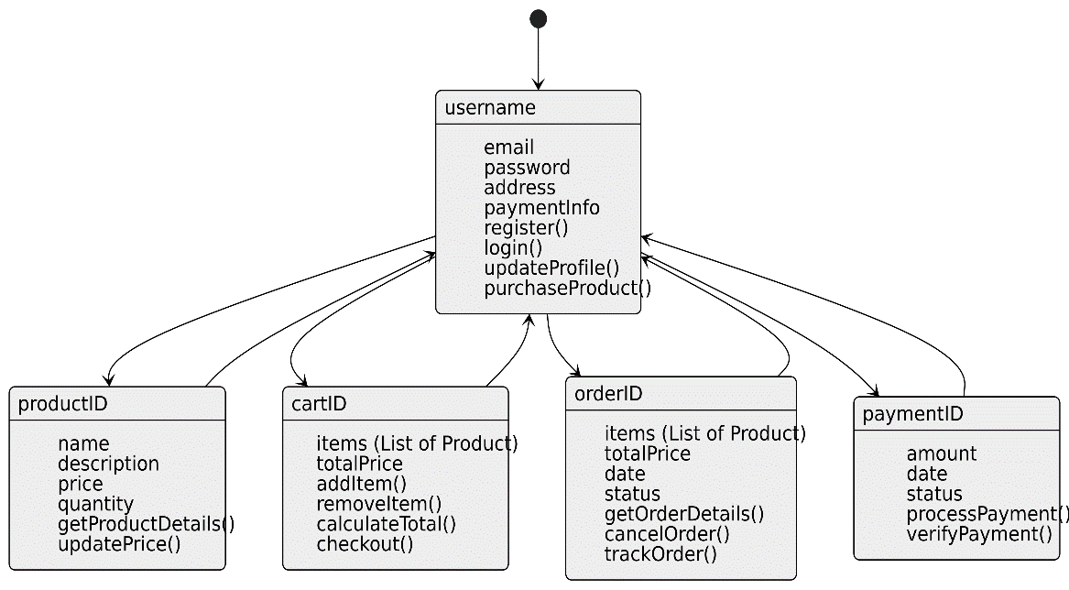

1. **Usecase Diagram.**

